**Rheem Cooling Website – Project Report**

Edulink International College

Course: Front-End Development

[GitHub Repo](https://github.com/ovonover/Rheem-Cooling-Website) , [Figma Design](https://www.figma.com/file/MuOzNuWmlCi3lJrH5VtPtz?node-id=0-1&p=f&t=v7V7wGLJhmcpLzz6-0&type=design&mode=design&fuid=1430474109082944221) , [Website](https://rheem-cooling-website.vercel.app/)  
* Check out the Figma Design link, It has some additional information.

**1. Introduction**

The Edulink Rheem Cooling Website is a front-end development project undertaken as part of the curriculum at Edulink International College.

The project aims to provide a dynamic, user-friendly platform where users can view and search for air conditioners, compare options, and explore a variety of ACs.

The website offers a streamlined approach for ACs buyers to interact with listings through filters, and reviews.

**2. Team Members and Roles**

The project was developed by a team of four students, each contributing specific skills to ensure successful delivery:

Ali – Team Leader / Project Manager.

Ali & Theodora – UI/UX Designers.

Theodora, Sophia & Shamim – HTML & CSS Developers.

Ali – React Developer.

Shamim & Ali – Documentation Leaders.

**3. Project Objective**

The primary objective of the Rheem Cooling Website is to create a responsive and intuitive platform that showcases available ACs for sale.

**Key goals include:**

Displaying various ACs with:

Models:

**Specifications:**

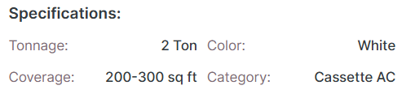

**Key Features:**

**Simple Descriptions:**

**Prices:**

**Services:**

Allowing users to rate ACs

**Users can filter through the products displayed on the website:**

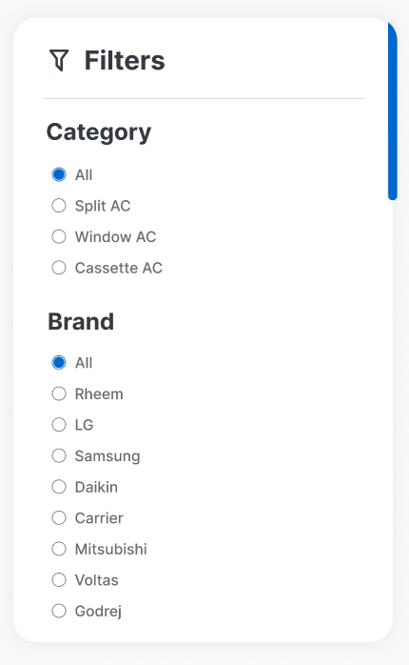

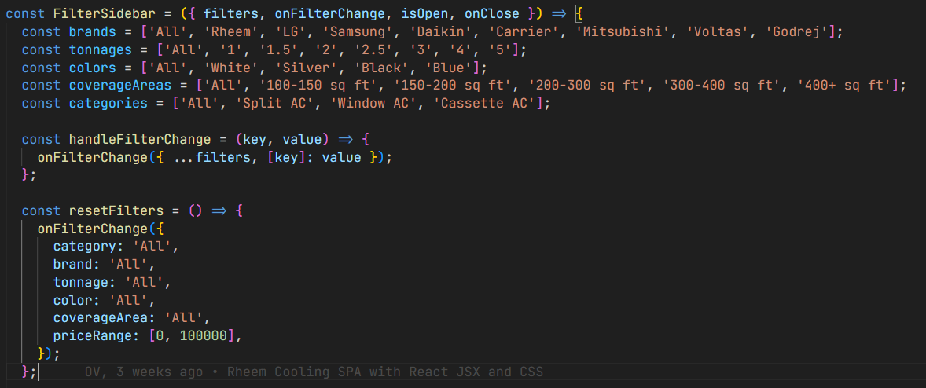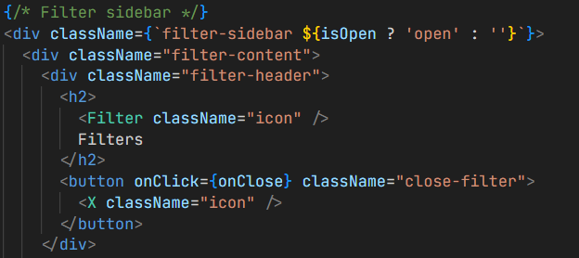

**A gallery where users can view pictures of different ACs**

**Each model of ACs has their specific category for easy User Experience:**

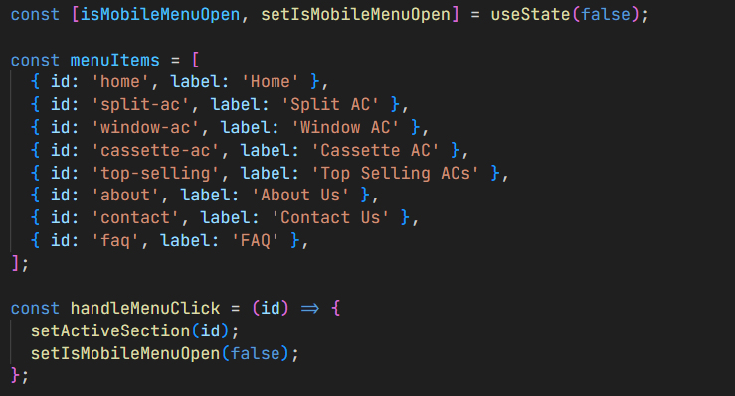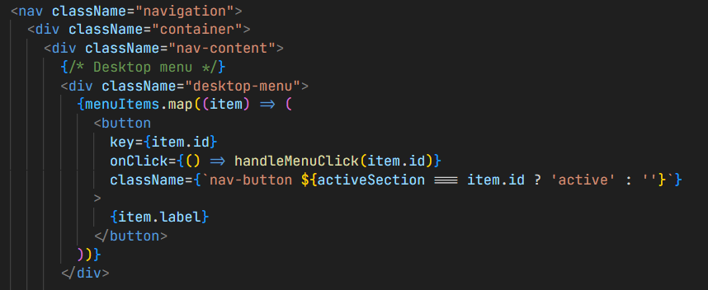

**4. Technology Stack**

The following technologies were used in the development of the website:

HTML – for page structure

CSS – for styling and layout

JavaScript – for interactivity

React – for building dynamic user interfaces

**5. Core Features**

The Rheem Cooling Website includes the following core functionalities:

AC Products: Display of all available ACs with details such as prices, model, and Specifications.

User Ratings: Visitors can leave ratings and feedback on ACs.

Search & Filter Options: Advanced filters by tonnage, color, brand, and price range.

Cart list: Users can add products to their cart and view them.

**6. Development Process**

The Waterfall Methodology was used to develop the project, and the following steps were taken in order:

- Analysis of Requirements   
  
- Creating & Execution Examining   
  
- Implementation   
  
- Records

**7. Challenges Faced**

The team faced several obstacles while developing:   
  
Team Coordination: Because individual availability varied, it was occasionally challenging to schedule and align responsibilities.   
  
Technical Challenges: A few team members' machines crashed, which caused delays in work.   
  
Version Control: Inadequate knowledge of Git resulted in ineffective code management and teamwork.

**8. Conclusion and Future Improvements**

The Rheem Cooling Website successfully delivers a functional and visually appealing platform for AC buyers. While the front-end is currently operational, future improvements include:

Back-End Development: Using PostgreSQL or MySQL to store user data, AC listing, and Products information

Enhanced Security: Introducing authentication and authorization for sellers and buyers

Mobile Responsiveness: Further optimization for mobile devices

This project has significantly contributed to the team’s understanding of front-end development practices and collaboration in real-world environments.

**FLOWCHARTS**

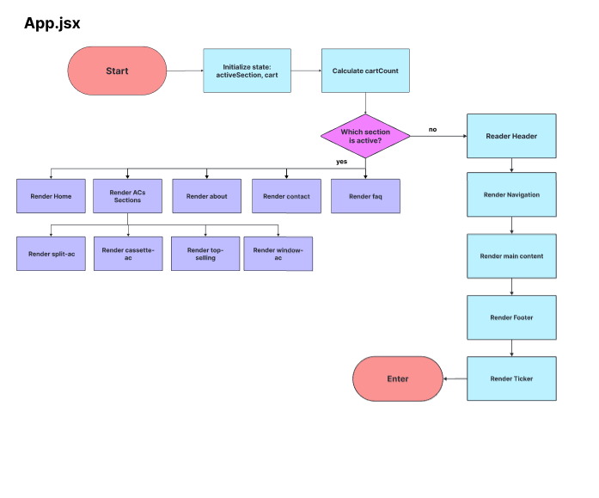

**User Guide:**

*Incase the code won’t start running right away you will have to follow these steps.

*1. Install Node.js*

*2. and also install react libraries “npm install” in the command prompt.*

*3. run the server “npm run dev”.*

*4. then open the link shown in the command prompt on your preferred browser.*

*5. then it should show the website working normally.*